Background:
YouTube's trending algorithm, which is updated every 15 minutes, plays a crucial role in determining the visibility and success of videos on the platform. The trending status of a video is influenced by several factors, including but not limited to:
- the number of views
- Age of video
- Temperature (how quickly it generates views)
- Where the views are coming from
- How the video compares to others from the same channel
A deeper understanding of these key contributing factors can provide valuable insights into how to enhance a video's performance and increase its likelihood of appearing on the trending list more frequently. Through this project, we aim to explore and analyze these factors to develop strategies that can potentially improve a video's chances of trending, thereby maximizing its reach and impact.

Objective
Using different modelling techniques, finding the best classifier model with the most accurate prediction of if a video will trend once or repetitively. This would help the user and other key stakeholders of the growth of a video: Would this video pop up in TouTube’s trending list again and have chance to gain more popularity?
Generally it has been understood that videos that are universally applicable/holding a lasting relevance and on topics of recurring events tend to positively favour videos in repeatedly popping up in trending list. The age of a video (time since it was uploaded) adversely affect it from reappearing in trending list.

Methodology:
- Data Cleaning & Wrangling:
The dataset features trending videos collected from 10 different countries (namely US, GB, DE, CA, FR, RU, MX, KR, JP and IN), and has 16 features, which are:

Feature | Data type | Feature | Data type
video_id | object | views | int64
publish_datetime | datetime64  [ns, UTC] | likes | int64
trending_date | datetime64  [ns] | dislikes | int64
title | object | comment_count | int64
channel_title | object | tags | object
category | object | comments_disabled | bool
category_id | int64 | ratings_disabled | bool
country | object
description | object

US and CA data was chosen from the 10 countries for how similar the video contents could possibly be, with primary emphasis placed on the following features: Views, Likes, Dislikes & Comment count.
Data cleaned for videos with ‘Deleted Video’ title or flagged by video_error_or_removed, missing description filled with ‘’ (blank string), and most importantly derived a few new features:
- Number of tags
- Number of repeats
- Trending category (One-time/Repeat)
- Age of video (time from publish to trending)
- Comments/Ratings flag – enabled/disabled
The data was shrunk to 1 record per video ID with feature ‘Trending category’ identifying it to be a One-time hit or a Repeat hit in trending list.

  - 2. Data Exploration
The data was observed to have balanced classes (data split One-time hit and Repeat hit in 1:1 ratio). A bar plot of data from ‘Repeat hit’ category reveals
- Most of the videos to have <=3 occurrences of repeats.
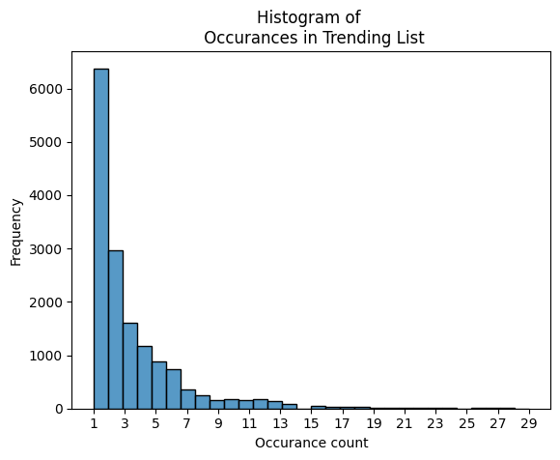
- 78% of data became popular 1 day after upload. Looking past that trend we notice the remainder of the data mostly lies in the range of Age < 5 and outliers which go as high as ~4200 days!
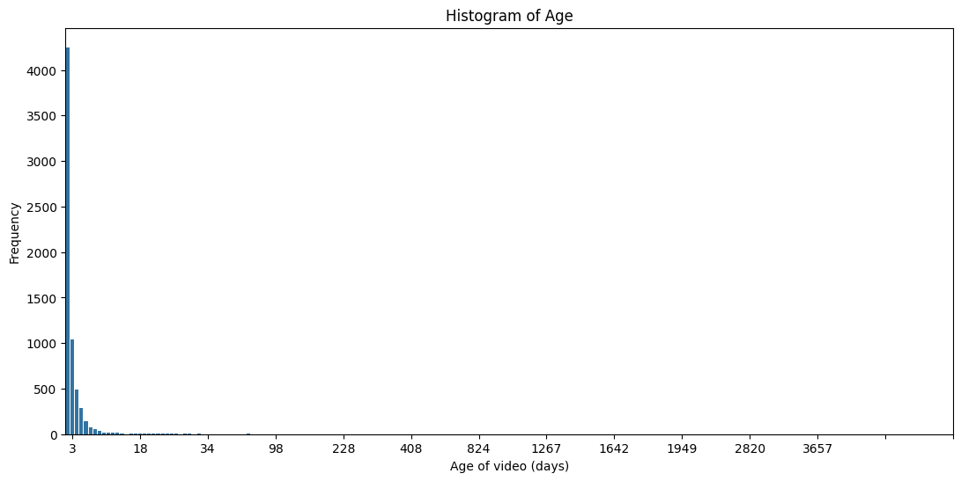
A box plot gives us a distribution of the numeric metrics per trending category.
- These show that view, likes, dislikes, and comment count likely plays a significant factor.
- Number of tags appeared to be surprisingly similar for both groups.
- Box plots for Age seemed different, but their median are almost identical, making this likely an ineffective contributing factor.

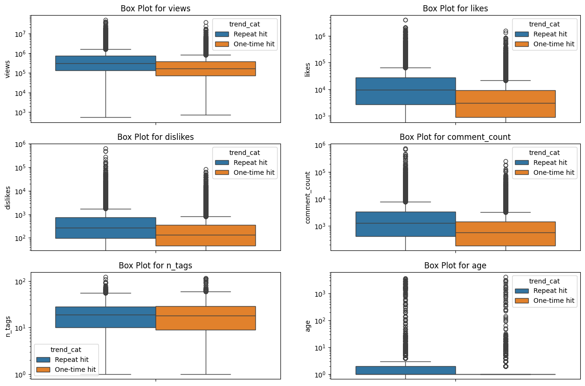

Outliers were tested using a 1D scatter plot, there was significant amount of data which is 1000s-fold higher than the 95-percentile of data. These data could still play a critical role in helping us classify the data and hence retained.

Correlation heatmap helps us identify potentially strong candidates for impactful features.
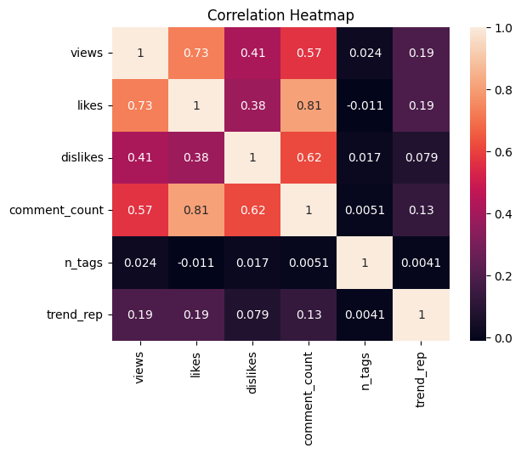
- Strong correlation = Likes vs. Comment count & Views
- Moderate correlation = Views vs. Dislikes & Comment count, Likes vs. Dislikes
- Minimal correlation = Number of tags & Trending repeats

- Preprocessing
Numeric metrics (views, likes, dislikes, age, n_tags & comment_count) were standardized with StandardScaler. Meanwhile categorical features (category, comments_status, & ratings_status) are encoded using OneHotEncoding. Trend category is selected as our predicted/dependent variable.
Training & validation data are split as 7:3 of original data.
- Modelling
Multiple models were selected for classification, although only 1 would be selected based on F1 score & Accuracy. Scikit Learn (sklearn) being very user friendly was the package choice for all models.

  - Logistic Regression (LR):
Logistic regression being a binary classifier was the initial choice since it’s a relatively simplistic model. It was hyper parameter tested using GridSearchCV for the ideal max_iter (Max. number of iterations) and C (regularization strength) parameters.
  - Parameters tested:
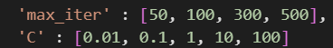
  - Best hyperparameters - 'C': 10, 'max_iter': 50

Performance metric: Its best model gives a 62.9% accuracy
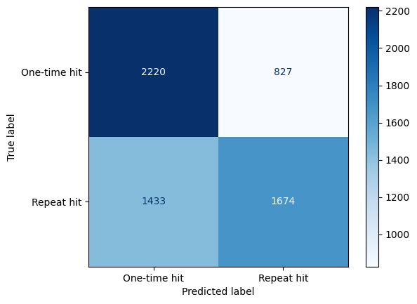
  - Support Vector Machine (SVM):
SVM was initially considered but later discarded because of the highly interspersed data that we deal with here (non-linear data).
  - Random Forest (RF):
RF is an emsemble method that leverages the power of multiple decision trees to improve prediction accuracy. After the poor accuracy from LR, RF was an anticipated and very promising choice as a classifier here.
Hyper parameter tested for following values & parameters:
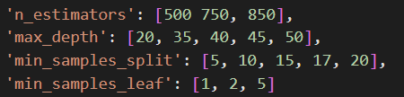
Best parameter-values identified (helps balance bias and variance):
- max_depth (max depth per tree): 40
- min_samples_leaf (min #samples required per node): 2
- min_samples_split (min #sample required to split a node): 20
- n_estimators (#Trees in forest): 850

Performance metric: 68.43% accuracy; A significant improvement over LR!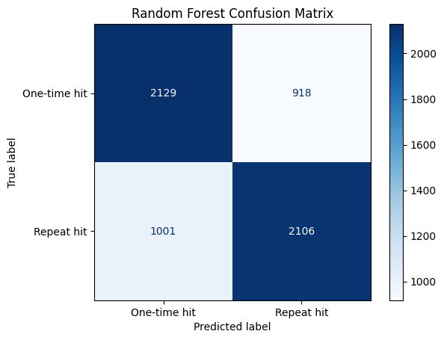
  - Gradient Boost (GB):
An ensemble method similar like RF, but works good for large datasets. Hyper parameter tested for following values & parameters:
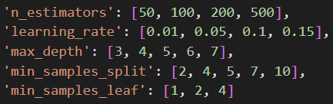
Best parameters-values identified:
- learning_rate (contribution per tree): 0.05
- max_depth (max depth per tree): 7
- min_samples_leaf (min #sample required in node): 1
- min_samples_split (max #sample for splitting a node): 7
- n_estimators (#Trees): 200
Performance metrics: 67.4% accuracy; Slightly poorer accuracy to RF.
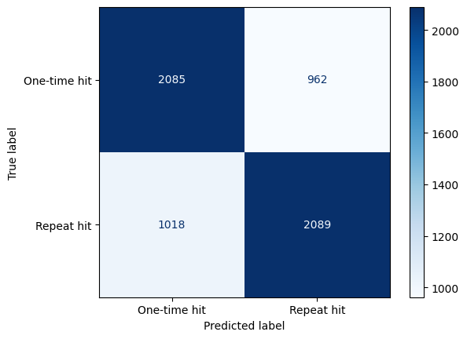
  - Stacked model (RF + GB):
Stacked generalization consists in stacking the output of individual estimators (namely Random Forest & Gradient Boost) and use a classifier (=XGB classifier) to compute the final prediction. This is an innovative modelling technique deployed in hopes of surpassing RF’s accuracy. The best hyper parameter tuned models from RF and GB were used as individual estimators.
Performance metric: 68.93% accuracy
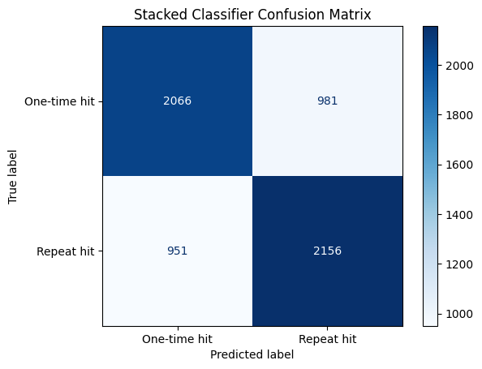

Conclusion
- Random Forest, Gradient Boosting and their Stacked model (RF+GB) performed the best, with very similar accuracy. Listed are scores from all models:
- Logistic Regression:
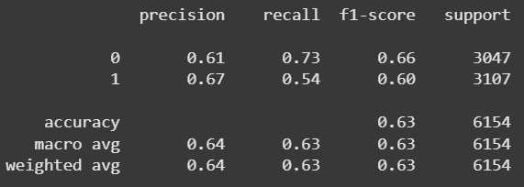
- Random Forest:
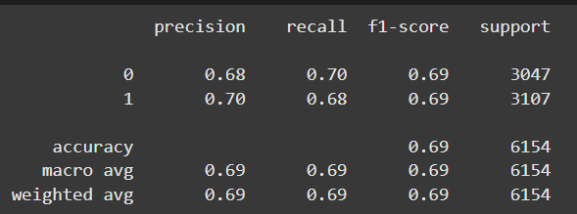
- Gradient Boost:
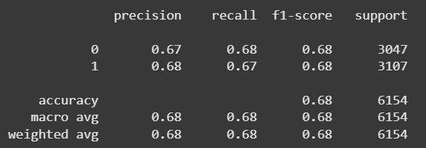
- Stacked model (GB + RF):
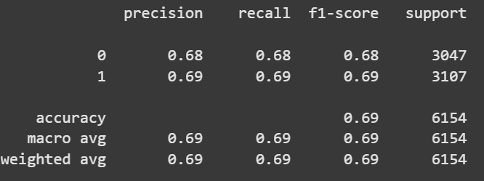
But the stacked model does not significantly boost the accuracy to justify its complexity. Thus, we choose Random Forest to be our best model for the data!
- Predicting this helps everyone from YouTube streamers to business analysts gauge if a trending video will generate more revenue. Instead of constantly tracking growth and engagement, creators could save time and focus on their next project.
- Despite the improved performance the RF model does not boast perfect accuracy. There a lot more work that could go into it to make it better!

Scope for Future Work
- The data used only 2 out of 10 countries in its analysis. Having a larger pool of data could perhaps reveal new trends that were not evident in this smaller pool.
- The modelling made use of 9 features. The correlation heatmap hinted that not all parameters are equally important for analysis. A feature selection could help weed out the lesser influential ones and perhaps boost accuracy further.
- The YouTube API is an easily accessible tool for pulling comments from each video. Title & description were features discarding in current analysis. A sentiment analysis of title, description & comments could possibly bring out more features to incorporate in analysis/modelling.
- While binary classification was a good starting point for this analysis, the classification could be broadened into the following using trending repeats (based on EDA results):
- Common repeats (1-2)
- Rare repeats (3-7)
- Epic repeats (8-15)
- Legendary repeats (>15)

